1. Demo upload and tag using Clarifai API after authenticated via MyInfo API

Load client

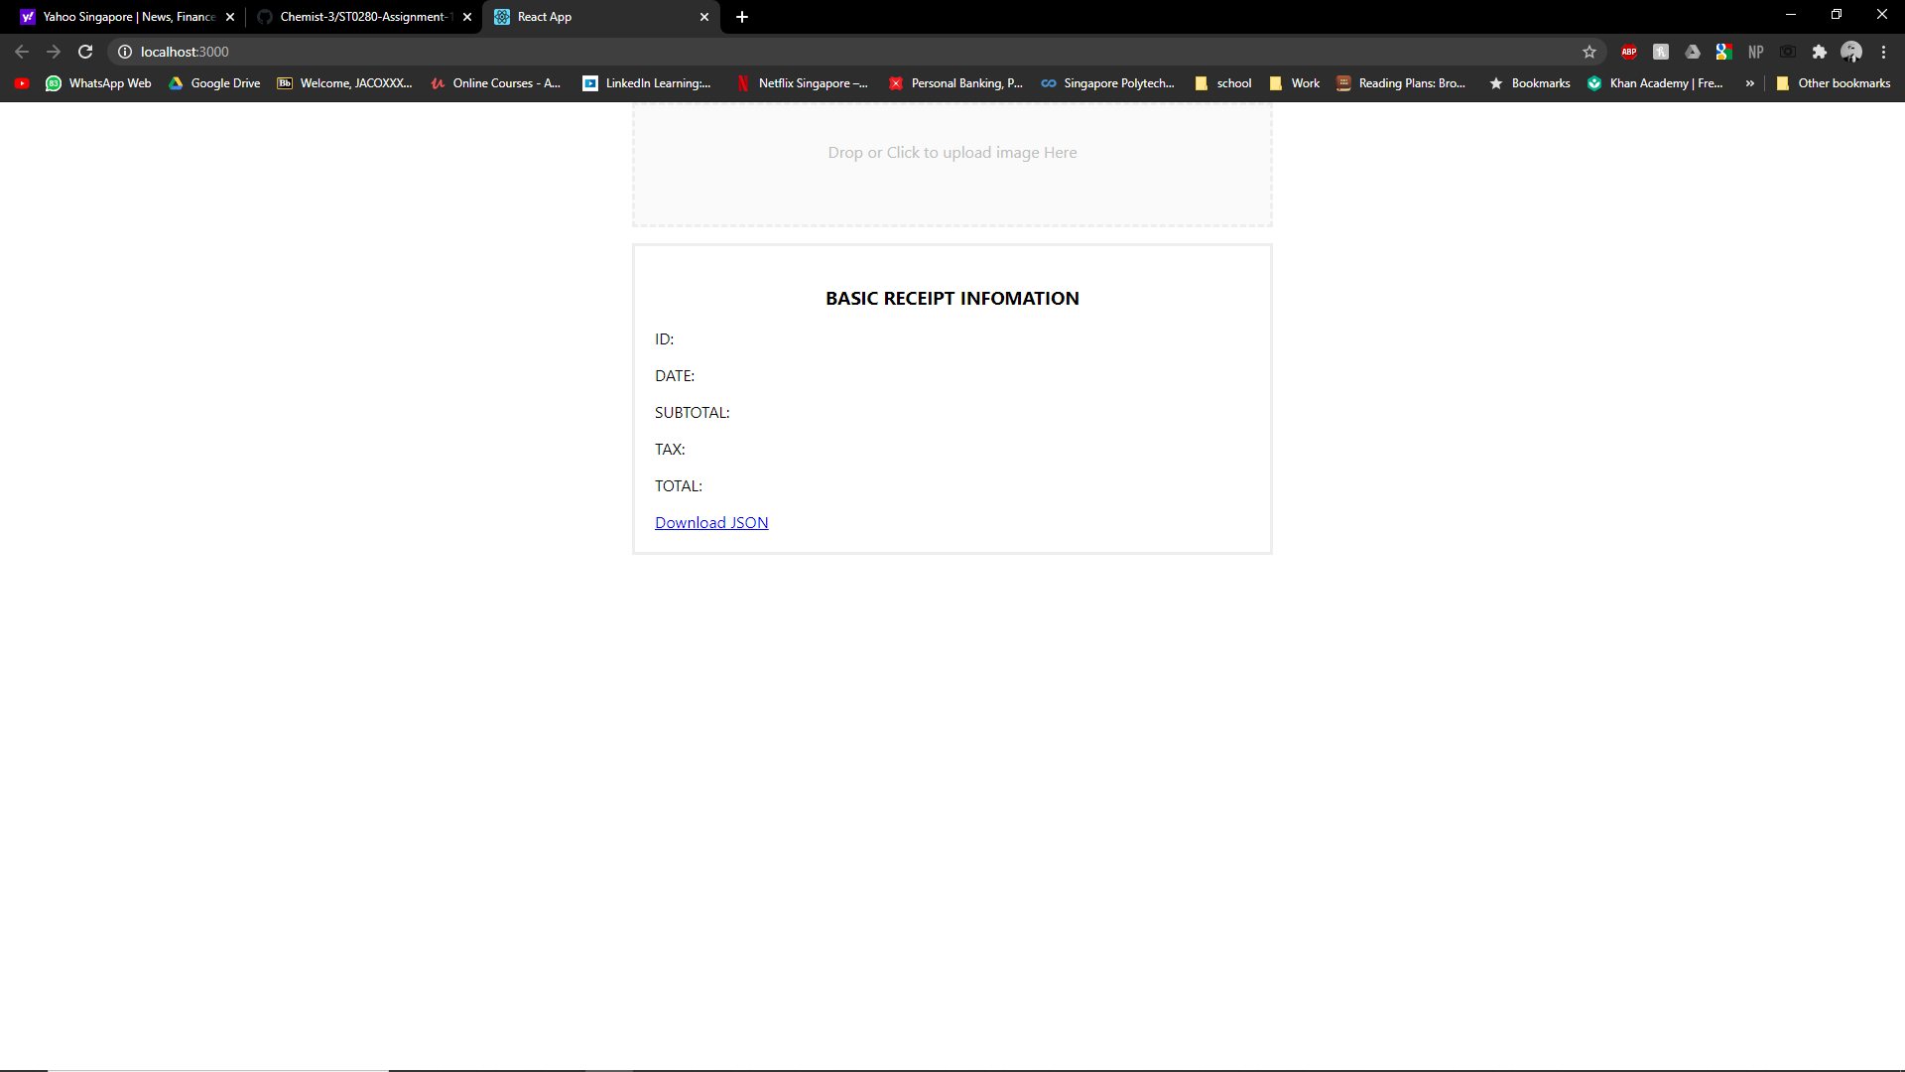

1. Demo image recognition using Clarifai API (i.e. image to text labels) using Image-Recognition-as-a-Service API .e.g Clarifai or others
   1. Recognise the images are receipts or not and the amount of the receipt

Loaded file into client

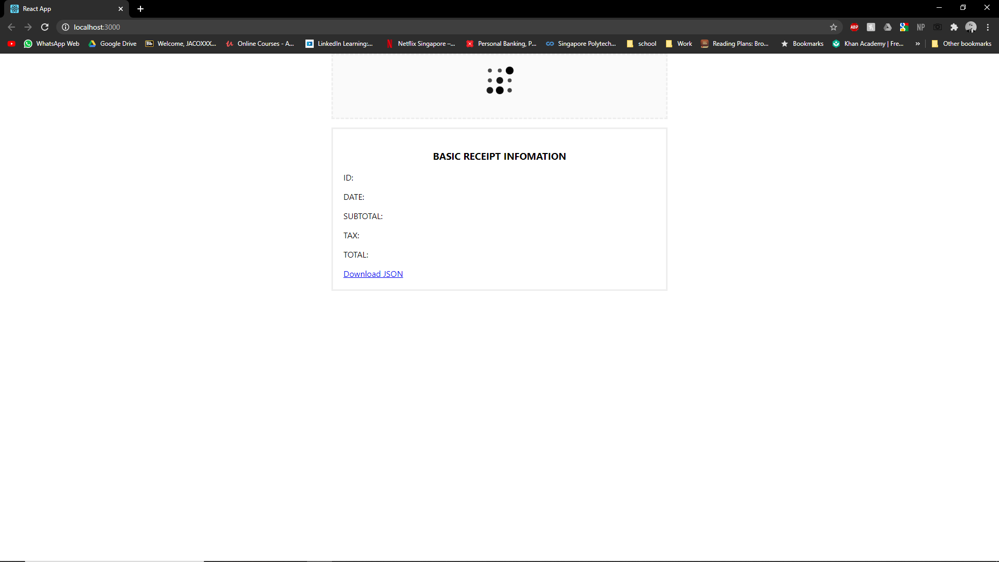

Laoded and tagging done

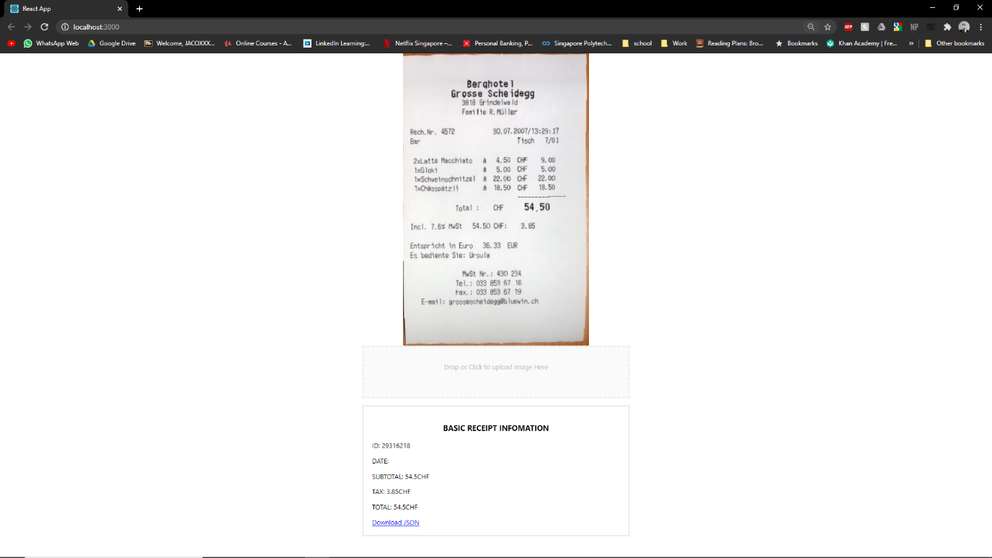

sequence diagram in sequence diagram branch in the git repository